Exercises

**Q1. Consider a database LOANS with the following tuples:**

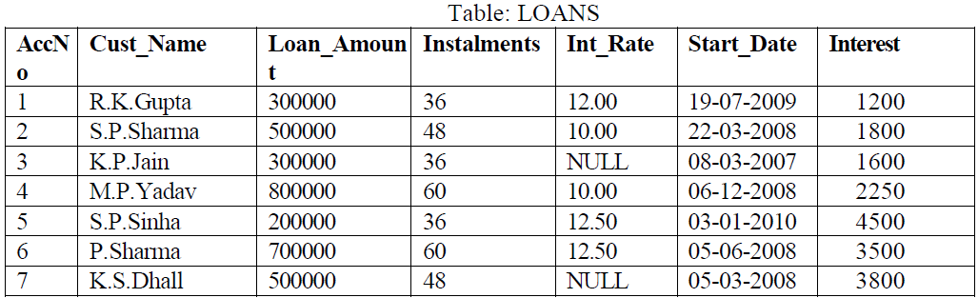

1. Create the table Loans and insert tuples in it.

create table loan (ac_no, cus_name varchar(25),loan_amt integer,Instalments integer,int_rate integer,start_date date, Interest integer);

1. Display the details of all the loans.

**select *from loan;**

AC_NO CUS_NAME LOAN_AMT INSTALMENTS INT_RATE START_DAT INTEREST

---------- ------------------------- ---------- ----------- ---------- --------- ----------

1 r k guptha 300000 36 12 19-SEP-09 1200

2 sp.sharma 500000 48 10 22-MAR-08 1800

3 k p jain 300000 36 08-MAR-07 1600

4 m p yadav 800000 60 10 06-DEC-08 2250

4 s p sinha 200000 36 13 03-JAN-10 4500

6 p sharma 700000 60 13 05-JUN-08 3500

7 k s dhall 500000 48 0 5-MAR-08 3800

7 rows selected.

1. Display the AccNo, Cust_Name, and Loan_Amount of all the loans.

**select ac_no,cus_name,loan_amt from loan**;

AC_NO CUS_NAME LOAN_AMT

---------- ------------------------- ----------

1 r k guptha 300000

2 sp.sharma 500000

3 k p jain 300000

4 m p yadav 800000

4 s p sinha 200000

6 p sharma 700000

7 k s dhall 500000

7 rows selected.

Conditional Select using Where Clause

1. Display the details of all the loans with less than 40 instalments.

**select * from loan where instalments<40;**

AC_NO CUS_NAME LOAN_AMT INSTALMENTS INT_RATE START_DAT INTEREST

------ ------------------------- ---------- ----------- ---------- --------- ----------

1 r k guptha 300000 36 12 19-SEP-09 1200

3 k p jain 300000 36 08-MAR-07 1600

4 s p sinha 200000 36 13 03-JAN-10 4500

1. Display the AccNo and Loan_Amount of all the loans started before 01-04-2009.

**select ac_no,loan_amt from loan where start_date<'01-apr-2009';**

AC_NO LOAN_AMT

---------- ----------

2 500000

3 300000

4 800000

6 700000

7 500000

1. Display the Int_Rate of all the loans started after 01-04-2009.

**select ac_no,loan_amt from loan where start_date>'01-apr-2009';**

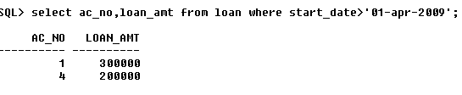

Using NULL

1. Display the details of all the loans whose rate of interest is NULL.

**select * from loan where int_rate is NULL;**

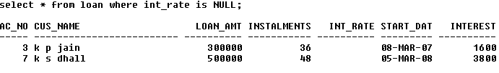

1. Display the details of all the loans whose rate of interest is not NULL.

**select * from loan where int_rate is NOT NULL;**

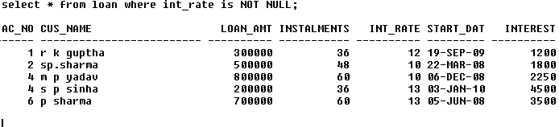

Using DISTINCT Clause

1. Display the amounts of various loans from the table LOANS. A loan amount should appear only once.

**select distinct loan_amt from loan;**

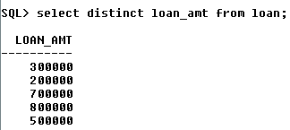



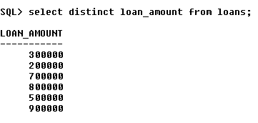

1. Display the number of installments of various loans from the table LOANS. An instalment should appear only once.

**select distinct instalments from loan;**

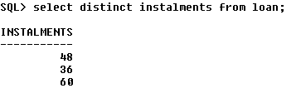

Using Logical Operators (NOT, AND, OR) and Between

1. Display the details of all the loans started after 31-12-2008 for which the number of instalments are more than 36.

select * from loan where start_date>'31-dec-08' and instalments<36;



1. Display the Cust_Name and Loan_Amount for all the loans which do not have number of instalments 36.

**select cus_name,loan_amt from loan where not(instalments=36);**

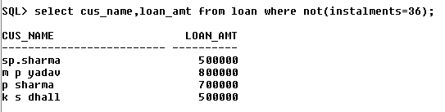

1. Display the Cust_Name and Loan_Amount for all the loans for which the loan amount is less than 500000 or int_rate is more than 12.

**select cus_name,loan_amt from loan where(loan_amt<500000 and int_rate>12);**

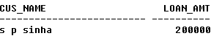

1. Display the details of all the loans whose Loan_Amount is in the range 400000 to 500000.

**select * from loans where loan_amt in(400000,500000);**

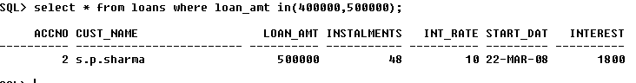

1. Display the details of all the loans whose rate of interest is in the range 11% to 12%.

**select * from loan where int_rate between 11 and 12;**

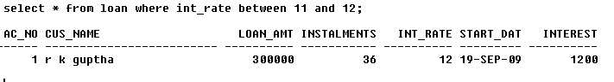

Using IN Operator

1. Display the Cust_Name and Loan_Amount for all the loans for which the number of installments are 24, 36, or 48. (Using IN operator)

**select cus_name,loan_amt from loan where instalments in(24,36,48);**

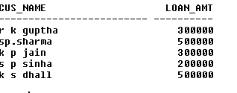

Using LIKE Operator

1. Display the AccNo, Cust_Name, and Loan_Amount for all the loans for which the Cust_Name ends with 'Sharma'.

**select ac_no,cus_name,loan_amt from loan where cus_name like '%sharma';**

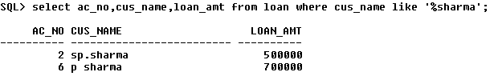

1. Display the AccNo, Cust_Name, and Loan_Amount for all the loans for which the Cust_Name ends with 'a'.

**select ac_no,cus_name, loan_amt from loan where cus_name like '%a’;**

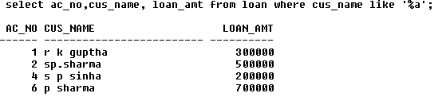

1. Display the AccNo, Cust_Name, and Loan_Amount for all the loans for which the Cust_Name contains 'a'.

**select ac_no,cus_name,loan_amt from loan where cus_name like '%a%';**

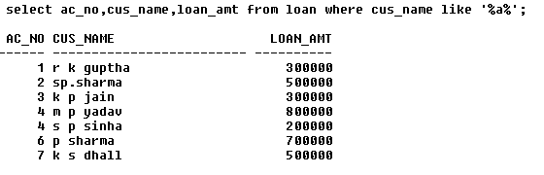

1. Display the AccNo, Cust_Name, and Loan_Amount for all the loans for which the Cust_Name does not contain 'P'.

**select ac_no,cus_name,loan_amt from loan where not(cus_name like '%p%');**

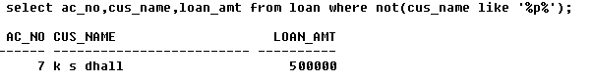

1. Display the AccNo, Cust_Name, and Loan_Amount for all the loans for which the Cust_Name contains 'a' as the second last character

**select ac_no,cus_name,loan_amt from loan where cus_name like '%a_';**

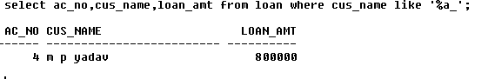

Using ORDER BY clause

1. Display the details of all the loans in the ascending order of their Loan_Amount.

**select * from loan order by loan_amt;**

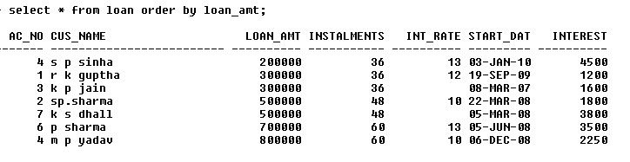

1. Display the details of all the loans in the descending order of their Start_Date.

**select * from loan order by loan_amt desc**;

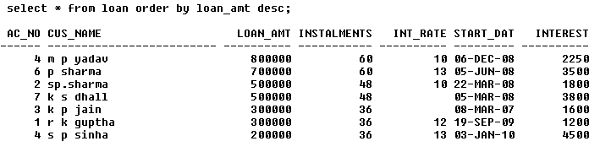

Using UPDATE, DELETE, ALTER TABLE

1. Put the interest rate 11.50% for all the loans for which interest rate is NULL.
2. Increase the interest rate by 0.5% for all the loans for which the loan amount is more than 400000.

**update loan set int_rate=int_rate +0.5 where loan_amt>400000**;

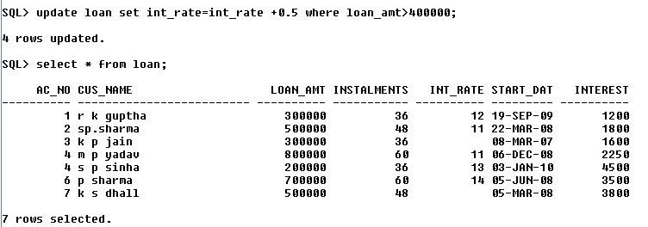

1. For each loan replace Interest with (Loan_Amount*Int_Rate*Instalments) 12*100.

**update loan set interest=(loan_amt*int_rate * instalments)/12*100;**

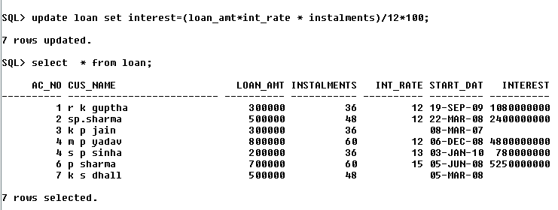

1. Delete the records of all the loans of 'K.P. Jain'

**delete loan where cus_name='k p jain'**;

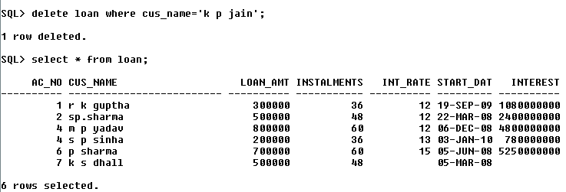

1. Add another column Category of type CHAR(1) in the Loan table.

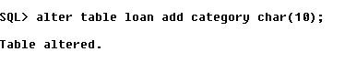

Using Aggregate Functions

1. Display the sum of all Loan Amount for whose Interest rate is greater than 10.

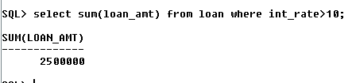

1. Display the Maximum Interest from Loans table.

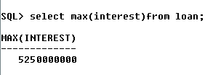

1. Display the count of all loan holders whose name is ending with ‘Sharma’.

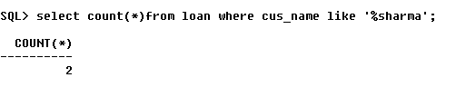

1. Display the count of all loan holders whose Interest is Null.

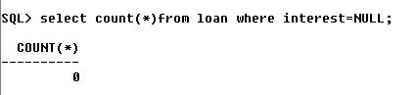

Using Group By Clause

1. Display the Interest wise details of Loan Account Holders.

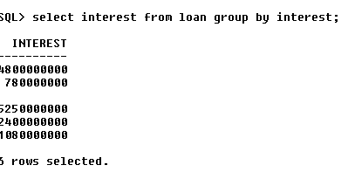

1. Display the Interest wise details of Loan Account Holders with at least 10 installments remaining.

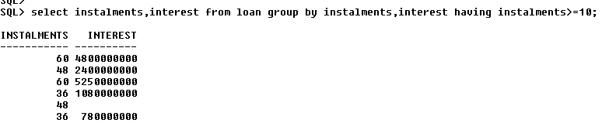

1. Display the Interest wise count of all loan holders whose Installment due is more than 5 in each group.

